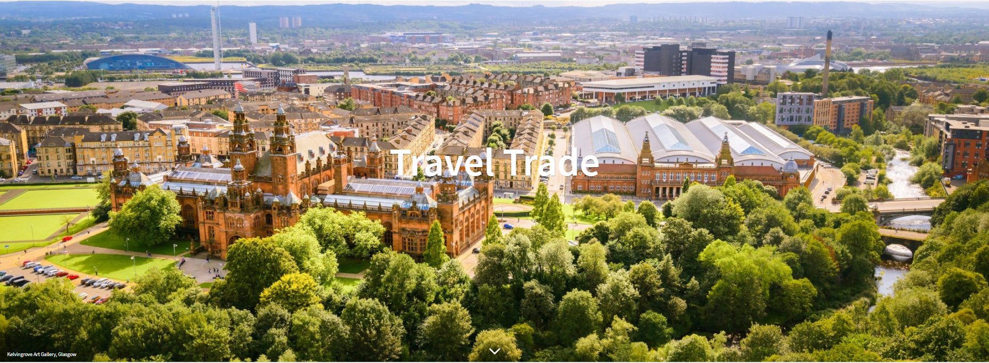
SUPPLIER DATA COLLECTION FORM FOR www.visitscotlandtraveltrade.com
Business Name of Supplier:

Contact Name:

Description (no more than 80 Words) :

Contact Telephone:

Contact Email:

Website:

Commission:

(Must be completed)

Address including postcode:

Supplier Type: (Please choose up to 5)

Accommodation* | VC | Activity
Events | V | Tour Operator
Golf |  | Transport
Food and Drink |  | Visitor Attraction
Ancestral |  | Exclusive Use
Youth |  | Luxury
Accessible |  | Private Tours
Agritourism/Farms |  | Responsible
DMC |  | Cruising/Shore Excursions
Walking Tours |  | Weddings

* If accommodation is selected, please complete Short Term Let legislation compliance on page 4.

Opening months:
Open all year | VC | (if not open all year, please tick the opening months)
January | V | May |  | September | VC
February |  | June |  | October
March |  | July |  | November
April |  | August |  | December

Image(s) supplied (please tick)

Your listing will not be uploaded without at least one image, and you can supply up to 5.
If you would be happy for your images to be used across other VisitScotland content (e.g. e-zines), please also complete Asset licence agreement.

Hints to improve your listing
- B2B Tone of voice i.e., your clients can enjoy; group friendly; easy coach parking; Groups and FIT; café can accommodate up to xx coaches; bespoke/private groups.
- Tour operators/agents who are looking at these listings may not be very familiar with Scotland – if relevant, indicate proximity to airports as this can make a difference when planning itineraries
- Commission: This MUST BE COMPLETED. Commission rate - 5%, 8%, 10%, 12%, 15%, 20%, 25%, 30%, 40% or Price on Application. An option to indicate zero commission is a wasted opportunity. Tour operators/agents are looking for a commission so they can ‘package’ up their programme. If the business has a number of commission options, then they can say POA (price on application) which is recognisable / understood within the travel trade.
- Choose up to 5 (if relevant) categories. An attraction can be a Visitor Attraction and a Food & Drink i.e., they can increase their foot traffic by attracting coaches/groups/FITs to their café to get business through the door. However, please ensure copy/imagery relate to these different product offerings to different clients within their listing.
Terms and Conditions (please tick)
By ticking this box, you confirm that you have read and agreed to our Terms and Conditions.

Short Term Let legislation compliance

Unless exempt, short-term let businesses are required to have a short-term lets licence to advertise on VisitScotland.com, the details of which must be displayed on your web listing.
Your business may be excluded from this legislation, for example, if you are licensed accommodation or a hotel with planning consent. A full definition of a short-term let and licensing scheme exclusions can be found on the Scottish Government website.

- Do you have a short-term lets licence for your property? (required)  Please mark applicable box below: |  | Next step
- Yes, I have a short-term lets licence for my property. |  | Go to Q2
- No, I applied before 1 October 2023 and am waiting for the decision on my application. |  | Go to Q3
- No, my business is excluded from the short-term lets licensing scheme. |  | Go to Q4

- Please provide the following details about your short term let licence:
  - . What type of short term let licence do you have? Mark the applicable box:
- Full (first licence)
- Full (renewed licence)
- Provisional
- Temporary
  - . Please enter you short term let licence number:
- . When does your short term let licence expire? |  |  |  |  |  |  |  |  |  |  |  | dd/mm/yyyy
  - . What is the maximum number of guests allowed to stay in the property?
  - . What is your properties Energy Performance Certificate (EPC) rating?
If not required select n/a

A |  | B |  | C |  | D |  | E |  | F |  |  | G |  | n/a

* If you require multiple STL licences, please copy the above box for each licence.

- Was your property established as a business before 1 October 2022?  Please mark applicable box below |  | Next step
- Yes, my property was established as a business before 1 October 2022 and I applied for a licence before 1st October 2023. |  | What date did you apply?  dd/mm/yyyy
- No, my property was established as a business on or after 1 October 2022 or I applied for a licence on or after 1st October 2023. |  | If your business was established on or after 1 October 2022 and you have not yet applied / are waiting on your licence being granted we will NOT be able to process your request for a web listing until your short-term let licence has been granted. Please do not submit us this form until you have this in place as we cannot create a listing for you.

- Please provide the reason for your business being excluded from the short-term lets licensing scheme.
- Accommodation which can be used as transport
- Accommodation which needs a licence for use for hire for overnight stays
- Accommodation which is provided by the guest
- Aparthotels
- Bothy - a building of no more than 2 storeys that has no mains electricity/piped fuel or water supply
- Holiday caravan / glamping post sited within a park with a caravan site licence
- Hostel
- Hotel that have planning permission granted for use as a hotel
- Premises which has a licence to sell alcohol under the Licensing (Scotland) Act 2005
- Self-catering within the grounds of a licenced premises if included on operational plan
- Student accommodation
- Other
If other, please state:

